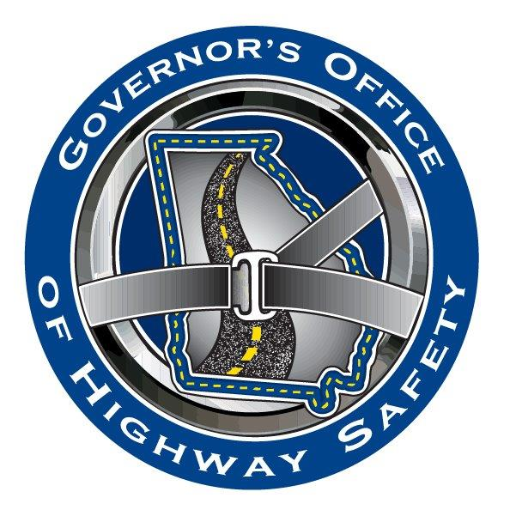
For More Information:
CONTACT NAME
CONTACT NUMBER
Your Agency’s Logo CONTACT EMAIL

NEWS RELEASE
DATE

Governor’s Office of Highway Safety Awards [Name/Type] Grant To
[Your Organization]

(YOUR CITY/COUNTY) [Your Organization] is pleased to announce it has received a [$ Amount of Grant] from the Governor’s Office of Highway Safety (GOHS). The grant, which will continue through September of 2024, will help finance…[describe the goals of the grant and what the money will be used for].

“The loss of one life on our roads is one too many, and the fact almost all fatal traffic crashes can be prevented is one reason why we are awarding this grant,” Allen Poole, Director of the Governor’s Office of Highway Safety said. “The target of zero traffic deaths in our nation is achievable, and we will continue to help develop and implement educational messages, enforcement campaigns, and other safety initiatives aimed at bringing us one step closer to our goal.”

“[Insert quote from your organization’s spokesperson]”

[Your Organization]…[give a brief description of organization’s history, mission, etc.]

For more information on the [Your Agency]’s award, contact [Agency Contact with Phone Number and Email Address]. For more information on GOHS and its highway safety programs visit www.gahighwaysafety.org.

